1. **Self-Introduction:** Address all of the following questions to introduce yourself.
   1. How long have you been in the Computer Science program?

I have been in this program since 2023. Before this program, I was in another that taught me how to create web applications using DynamoDB as the database. I first encountered computer science as a high school course where we created an atm app.

* 1. What have you learned while in the program? List three of the most important concepts or skills you have learned.

While taking this program, I have learned many concepts and rules to follow when it comes to software engineering. One concept is that of professional, clean code that follows up-to-date practices and can be changed without having to rewrite the entire program following a modular style. Another concept is separation of concerns by keeping the frontend and backend separate. A third concept I have learned is reverse engineering and how it is used in software development to figure out what old legacy programs did and how to modernize them.

* 1. Discuss the specific skills you aim to demonstrate through your enhancements to reach each of the course outcomes.

The specific skills I aim to demonstrate include building a modular program with a clear separation of concerns, using a well structured file and folder organization with descriptive labels so that others can easily understand and improve upon it, fostering a collaborative environment. My communication skills will be demonstrated through professional quality deliverables, including accurate flowcharts and a well written report. My design approach will solve the given problems using computer science best practices, such as separation of concerns, which may result in more lines of code but ultimately leads to a more maintainable and effective program. I will also apply well founded techniques and tools, such as modular programming and appropriate compilers, to support development. Finally, I will demonstrate a security mindset by treating each user as a potential threat, implementing thorough safeguards, and maintaining detailed logging to ensure accountability.

* 1. How do the specific skills you will demonstrate align with your career plans related to your degree?

These skills align with my career plans because I plan on starting a business designing and managing web and mobile applications for small and growing businesses. These skills will allow me to build scalable, secure, and maintainable applications for my clients.

* 1. How does this contribute to the specialization you are targeting for your career?

This contributes to my specialization by giving me the ability to create web and mobile applications following up to date best practices so that my apps run smoothly, are secure, and are easy to manage long term.

1. **ePortfolio Set Up:**
   1. Submit a **screen capture** of your ePortfolio GitHub Pages home page that clearly shows your URL.
      1. You already have a repository in GitHub where you uploaded projects in previous courses. Your ePortfolio will reside in GitHub but can link to work at other sites, such as Bitbucket.
   2. Use the GitHub Pages link in the Resource section for directions on:
      1. How to create your GitHub website and publish code to GitHub Pages
      2. Issues, such as adding links to other sites
   3. Paste a screenshot of your GitHub Pages home page with your URL clearly showing in the space below.

1. **Enhancement Plan:** 
   1. **Category One:** Software Engineering and Design
      1. **Select an** **artifact** that is **aligned with** **the** software engineering and design **category** and explain its origin. Submit a file containing the code for the artifact you choose with your enhancement plan.

I will enhance my mobile event-tracking application from CS 360 (Mobile Architecture and Programming). This artifact currently uses Java and SQLite on Android Studio, and I will enhance it by recreating it as a web application in JavaScript using Node.js, Express, and MongoDB, using a MVC approach utilizing HBS and JSON.

Note: Your artifact may be work from the following courses:

* IT 145: Foundation in Application Development
* CS 250: Software Development Lifecycle
* CS 260: Data Structures and Algorithms
* IT 315: Object Oriented Analysis and Design
* CS 320: Software Testing, Automation, and Quality Assurance
* CS 330: Computational Graphics and Visualization
* CS 340: Advanced Programming Concepts
* CS 350: Emerging Systems Architectures and Technologies
* CS 360: Mobile Architecture and Programming
* IT 365: Operating Environments
* IT 380: Cybersecurity and Information Assurance
* CS 405: Secure Coding
* CS 410: Reverse Software engineering
* IT 340: Network and Telecommunication Management
* IT 380: Cybersecurity and Information Assurance
  + 1. **Describe** a practical, well-illustrated **plan** for enhancement in alignment with the category, including a pseudocode or flowchart that illustrates the planned enhancement.

My enhancement plan is to refactor and transfer the project into a web stack that separates frontend, backend, and database layers using JavaScript and Json. I will implement user authentication with hash + salt, design modular routes/controllers, and ensure clean code structure.

For this category of enhancement, consider improving a piece of software, transferring a project into a different language, reverse engineering a piece of software for a different operating system, or expanding a project’s complexity. These are just recommendations. Consider being creative and proposing an alternative enhancement to your instructor.

Think about what additions to include to complete the enhancement criteria in this category. Since one example option is to port to a new language, that is the kind of scale that is expected. This does not mean you need to port to a new language but instead have an equivalent scale of enhancement. Underlying expectations of any enhancement include fixing errors, debugging, and cleaning up comments, but these are not enhancements themselves.

* + 1. Explain how the planned enhancement will **demonstrate** specific **skills** and align with course outcomes.
       1. Identify and describe the specific skills you will demonstrate that align with the course outcome.

The specific skills I will demonstrate are separation of concerns, modular design, secure authentication, clean code refactoring, and modern web stack development.

* + - 1. Select one or more of the course outcomes below that your enhancement will align with.

CO3: Design and evaluate computing solutions using algorithmic principles and standards while managing trade-offs.

CO4: Demonstrate innovative techniques, skills, and tools in computing practices for delivering industry-specific solutions.

CO5: Develop a security mindset that anticipates exploits and ensures privacy and security of data.

Course Outcomes:

1. Employ strategies for building collaborative environments that enable diverse audiences to support organizational decision-making in the field of computer science.
2. Design, develop, and deliver professional-quality oral, written, and visual communications that are coherent, technically sound, and appropriately adapted to specific audiences and contexts.
3. Design and evaluate computing solutions that solve a given problem using algorithmic principles and computer science practices and standards appropriate to its solution while managing the trade-offs involved in design choices.
4. Demonstrate an ability to use well-founded and innovative techniques, skills, and tools in computing practices for the purpose of implementing computer solutions that deliver value and accomplish industry-specific goals.
5. Develop a security mindset that anticipates adversarial exploits in software architecture and designs to expose potential vulnerabilities, mitigate design flaws, and ensure privacy and enhanced security of data and resources.
   1. **Category Two:** Algorithms and Data Structures
6. **Select an artifact** that is **aligned with the** algorithms and data structures **category** and explain its origin. Submit a file containing the code for the artifact you choose with your enhancement plan. You may choose work from the courses listed under Category One.

I will enhance the same mobile event-tracking application from CS 360 that I used in Category One. Instead of focusing on the design and engineering aspects, I will focus here on data structures and algorithms. This artifact stores user events and user login information with attributes such as title, description, and time, and retrieves them for display.

1. **Describe** a practical, well-illustrated **plan** for enhancement in alignment with the category, including a pseudocode or flowchart that illustrates the planned enhancement.

I will enhance the artifact by converting it from a mobile only SQLite application into a web application that uses MongoDB while keeping the same underlying data structure for events and users login. This ensures consistency and allows me to demonstrate how the same algorithms and data structures can function across different platforms.

I will also enhance it further by making the app cross platform compatible so that events can be stored, queried, and displayed on both mobile and web. The data structure will support features like filtering by date, searching by title, and sorting events efficiently.

For this category of enhancement, consider improving the efficiency of a project or expanding the complexity of the use of data structures and algorithms for your artifact. These are just recommendations. Consider being creative and proposing an alternative enhancement to your instructor. Note: You only need to choose one type of enhancement per category.

Think about what additions to include to complete the enhancement criteria in this category. Since one example option is to port to a new language, that is the kind of scale that is expected. Perhaps you might increase the efficiency and time complexity of an algorithm in an application and detail the logic of the increased time complexity. Remember, you do not need to port to a new language but instead have an equivalent scale of enhancement. Underlying expectations of any enhancement include fixing errors, debugging, and cleaning up comments, but these are not enhancements themselves.

1. Explain how the planned enhancement will **demonstrate** specific **skills** and align with course outcomes.
   1. Identify and describe the specific skills you will demonstrate to align with the course outcome.

Applying the same data structures across platforms (event objects, user login, indexed queries). Designing algorithms for searching, filtering, and sorting events efficiently. Ensuring cross-platform compatibility by abstracting the data model so that mobile and web both use the same logic.

* 1. Select one or more of the course outcomes listed under Category One that your enhancement will align with.

CO3: Design and evaluate computing solutions that solve a given problem using algorithmic principles and computer science practices.

CO4: Demonstrate innovative techniques and tools in computing practices for implementing solutions that deliver value.

* 1. **Category Three: Databases**
     1. **Select an artifact** that is **aligned with the** databases **category** and explain its origin. Submit a file containing the code for the artifact you choose with your enhancement plan. You may choose work from the courses listed under Category One.

I will enhance the DatabaseHelper/SQLite code from my Android event-tracker application.

* + 1. **Describe** a practical, well-illustrated **plan** for enhancement in alignment with the category, including a pseudocode or flowchart that illustrates the planned enhancement.

I will replace the SQLite database with MongoDB. This requires restructuring the schema, migrating queries, and updating CRUD operations to use Mongoose (ODM). Users and Events will be linked via a userId reference, and authentication will use hash + salt password storage.

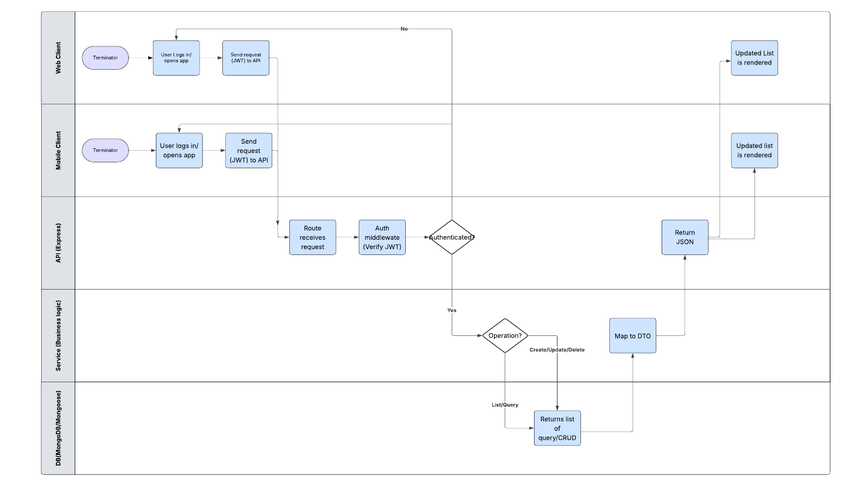

For this category of enhancement, consider adding more advanced concepts of MySQL, incorporating data mining, creating a MongoDB interface with HTML/JavaScript, or building a full stack with a different programming language for your artifact. These are just recommendations; consider being creative and proposing an alternative enhancement to your instructor. Note: You only need to choose one type of enhancement per category.

Think about what additions to include to complete the enhancement criteria in this category. Since one example option is to port to a new language, that is the kind of scale that is expected. Perhaps you might increase the efficiency and time complexity of an algorithm in an application and detail the logic of the increased time complexity. Remember, you do not need to port to a new language but instead have an equivalent scale of enhancement. Underlying expectations of any enhancement include fixing errors, debugging, and cleaning up comments, but these are not enhancements themselves.

* + 1. Explain how the planned enhancement will **demonstrate** specific **skills** and align with course outcomes.
       1. Identify and describe the specific skills you will demonstrate that align with the course outcome.

database migration, schema design, CRUD implementation, security integration (hash + salt), scalability with NoSQL.

* + - 1. Select one or more of the course outcomes listed under Category One that your enhancement will align with.

CO4: Demonstrate innovative skills and tools in computing practices.

CO5: Develop a security mindset to protect user data and ensure privacy.

1. **ePortfolio Overall Skill Set**
   1. Accurately describe the **skill set** to be illustrated by the **ePortfolio** **overall**.
      1. Skills and outcomes planned to be illustrated in the code review

Clean code design, modular structure, security first programming, migration of mobile systems to web system, separation of concerns, and proper use of algorithms/data structures.

* + 1. Skills and outcomes planned to be illustrated in the narratives

Ability to explain enhancements clearly, connect them to industry standards, and show how they align with professional goals.

* + 1. Skills and outcomes planned to be illustrated in the professional self-assessment

Reflection on growth as a software engineer, including technical skill development, problem-solving strategies, and how my work connects to career plans like building web and mobile apps for small businesses.